Image Sharpening Using Gradient Masking
Experiment No: 25
Aim
To perform sharpening of an image using Gradient Masking with gradient masks in Python using the OpenCV library.
Theory
Gradient masking is an image sharpening technique that uses the gradient of an image to detect edges and enhance them.
The two gradient masks shown in the question are:
Horizontal Gradient Mask (Gx)
Vertical Gradient Mask (Gy)
The gradient magnitude can be calculated as:
The detected gradient is then added to the original image to produce a sharpened image.
Tools Required
- Python 3.x
- OpenCV (cv2)
- NumPy
- VS Code / PyCharm / Jupyter Notebook
- Input image (image.jpg)
Procedure
- Install OpenCV and NumPy:
Bash
pip install opencv-python numpy
- Read the input image using OpenCV.
- Convert the image to grayscale.
- Define the horizontal and vertical gradient masks.
- Apply the masks using cv2.filter2D().
- Calculate the gradient magnitude.
- Add the gradient information to the original image.
- Display the original, gradient, and sharpened images.

Code
import cv2
import numpy as np

# Read the image
image = cv2.imread("image.jpg")

# Check if image is loaded
if image is None:
print("Error: Image not found!")
exit()

# Convert image to grayscale
gray = cv2.cvtColor(image, cv2.COLOR_BGR2GRAY)

# Convert to float for processing
gray_float = gray.astype(np.float32)

# Horizontal gradient mask (Gx)
Gx = np.array([
[-1, -2, -1],
[ 0, 0, 0],
[ 1, 2, 1]
], dtype=np.float32)

# Vertical gradient mask (Gy)
Gy = np.array([
[-1, 0, 1],
[-2, 0, 2],
[-1, 0, 1]
], dtype=np.float32)

# Apply gradient masks
gx = cv2.filter2D(gray_float, -1, Gx)
gy = cv2.filter2D(gray_float, -1, Gy)

# Calculate gradient magnitude
gradient = np.sqrt(gx**2 + gy**2)

# Normalize gradient to 0-255
gradient = cv2.normalize(
gradient, None, 0, 255, cv2.NORM_MINMAX
)

# Create sharpened image
sharpened = gray_float + gradient

# Clip values to valid range
sharpened = np.clip(sharpened, 0, 255).astype(np.uint8)

# Convert gradient to uint8
gradient = gradient.astype(np.uint8)

# Display images
cv2.imshow("Original Image", gray)
cv2.imshow("Gradient Image", gradient)
cv2.imshow("Sharpened Image", sharpened)

cv2.waitKey(0)
cv2.destroyAllWindows()

Output
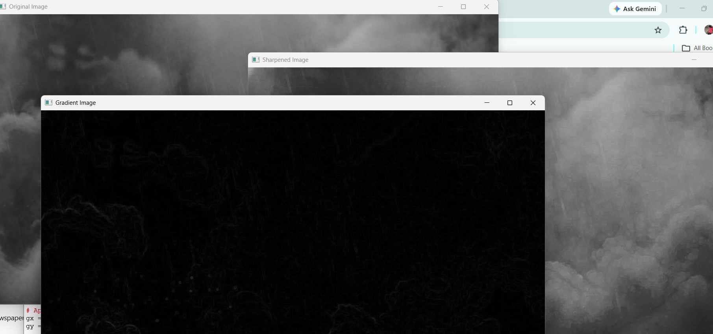
Result
The image was successfully sharpened using the Gradient Masking technique. The horizontal and vertical gradient masks were applied to detect edges, and the resulting gradient information was added to the original image to produce a sharpened image.

